Research Assignment 2

Kan Yuenyong (6220131004)

National Institute of Development Administration

Graduate School of Public Administration

PhD, Doctor of Philosophy Program in Governance and Development (International)

**1. Introduction**

As discussed in Krongkaew (1979: 3), in Thailand, there has been a need to address a problem of a reduction of income since 1970’s as mentioned as early as in the Third National Economic Development Plan written in 1972 and later to be more emphasized in The Fourth National Economic and Social Development Plan (1977-1981) to response with the then growing unrest, but there was no precise mechanism to track the implemented policies, “*what is still much lacking is the knowledge of basic understanding of how the government policies affect the distribution of income of the people*” (Krongkaew, 1979: 4). Therefore, he did the study to give this insight. This paper will follow Krongkaew’s study (1979) to demonstrate how we can utilize fiscal data to analyze impact on the income redistribution to the people.

**2. Research Questions**

Given data from fictitious country A, whether the policy can make better income redistribution among the people in the country?

**3. Literature Review**

There is a discussion of relationship between growth and equity in Krongkaew (1979: 7) such as we can choose only one objective among the two (Lewis, 1955), or to be identified in a pattern of inverted-U curve on the relationship pattern of growth and equity (Kuznets, 1963), in which such pattern has been empirically confirmed by both Kravis (1960) and Oshima (1962), as well as in Adelman and Morris (1971) and a time-series studies in Brazil by Fishlow (1973), in Mexico, Puerto Rico, and Argentina by Weisskoff (1970). However, as found in Ahluwalia (1974; 1976), contrary to Kuznets, it seems unnecessary that economic growth will always lead to greater inequality, albeit Ahluwalia has found that the cross-country data used in his study is not appropriate for this kind of research. The negative relation might rather happen in the short run. Those reviews are based in Krongkaew (1979: 7-12). Krongkaew (1979: 16) then suggests that it’s possible to use government as a tool for income redistribution which can be clarified into two categories which are either budgetary policies and non-budgetary policies. This study, however, will focus on budgetary policies only.

Krongkaew (1979: 38-57) has discussed extensively in the incidences of taxes that most developing countries tend to collect only a few direct taxes, Thailand has to depend on personal income tax and corporate income tax, mostly exempt to land and property tax; there is no capital gain tax (totally exempt), a lot of exemption on inheritance tax (> 100 million bath are subjected to 1 percent tax) therefor it needs to rely on few tax bases. Whenever there is a decrease in tax revenue, it seems majority of the rich tends to be exempt of tax and thus a failure in wealth redistribution. The burden of tax from indirect tax such as sale tax or VAT tend to be shifted to the consumer. This too will generate problem on income redistribution.

**4. Conceptual Framework**

In this study, we will use Tax Incidence Research to address the impact of income redistribution as follow:

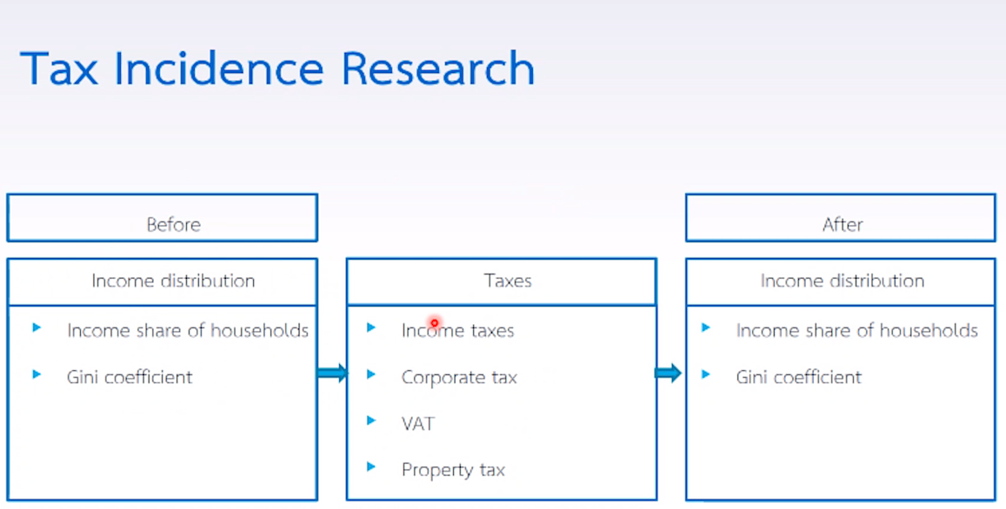

Figure 1: Research’s Conceptual Framework, Tax Incidence Research

**5. Research Methodology**

The study will calculate tax according to each stratum in the quintile and shifts in burden on each type of tax to each stratum in the quintile and then calculate the effective tax rate and thus to calculate post-tax income distribution respectively.

**5.1 Data Collection**

Data on household income distribution and expenditure pattern of household can be found on sources such as: (1) the national statistical office (see socio-economic survey of household, SES), The World Bank (see country study on Poverty Assessment Reports, World Development Indicator, and Expenditure Tacking Survey).

Data on tax revenue can be found on sources such as: the minister of finance, bureau of the budget, The World Bank (see World Development Indicators), The IMF (see International Financial Statistics and Government Financial Statistics).

**5.2 Data Analysis**

On this part, we will use tax incidence research as mentioned on conceptual framework section to analyze income redistribution impacted by tax policy. Table 1

Table 1: Household Income Distribution

|  |  |  |  |
| --- | --- | --- | --- |
| Income class | % of household | Income per month  (baht) (average) | % of income |
| 1. Lowest income  2. Low income  3. Middle income  4. High income  5. Highest income | Total = 15.8 million  20% (3,160,000)  20% (3,160,000)  20% (3,160,000)  20% (3,160,000)  20% (3,160,000) | 4,197  6,259  8,365  11,279  21,335 | 8.16  12.17  16.26  21.93  41.48 |
| Total | 100% | 51,434 | 100 |

Table 2: Consumption Expenditure Spent by Each Income Class

|  |  |  |  |  |
| --- | --- | --- | --- | --- |
| Income class | Proportion of Income spent on personal income tax (%) | Proportion of Income spent on General Consumption (%) | Proportion of Income spent on liquor and Tobacco (%) | Proportion of Income spent on Transportation (%) |
| 1. Lowest income  2. Low income  3. Middle income  4. High income  5. Highest income | 1.87  2.08  16.32  20.56  59.17 | 10.17  13.18  18.74  20.25  37.66 | 9.1  11.2  15.6  26.9  27.2 | 8.7  10.1  14.7  20.0  46.5 |
| Total | 100.00 | 100.00 | 100.0 | 100.0 |

Table 3: The distributional effect of tax by income class (million baht)

|  |  |  |  |  |  |  |
| --- | --- | --- | --- | --- | --- | --- |
| Type of tax | Total amount (Year 2010) | Income class | | | | |
| Lowest  income | Low  income | Middle income | High income | Highest income |
| 1. Personal Income Tax  2. Corporate Income Tax  3. VAT  4. Excise Tax  5. Import Tax | 153,920  288,500  376,400  -  - | 2,878.30  29,340.45  38,279.88  -  - | 3,201.54  29,340.45  38,279.88  -  - | 25,119.74  54,064.90  70,537.36  -  - | 31,645.95  58,431.25  76,537.36  -  - | 91,074.46  108,649.10  141,752.24  -  - |
| Total | 818,820 | 70,498.63 | 90,835.36 | 149,722.00 | 166,288.20 | 341,475.80 |
| Percent | 100.0 |  |  |  |  |  |

Result in table 3 has been calculate refers to table 2, in the assumption that personal income tax cannot be shifted to other people, therefore, taxpayers are assumed to bear the entire burden. Thus, we calculate respectively to the proportion to household expenditure on the tax, for example the lowest income will bear personal income tax as much as 153,920 * 1.87% = 2,878.30 million baht. All other strata in the quintile will be calculated similarly.

The corporate income tax, although the direct tax, but it can be shifted to the consumer due to non-competitive market condition especially in the developing countries, the burden of this tax will be passed onto the consumers proportionally, such as the low income will be shifted the burden as much as 288,500 * 13.18% = 29,340.45 million baht for example. All other strata in the quintile will be calculated similarly.

The VAT is an indirect tax, so it can be proportionally shifted to the consumer completely through the increasing in price tag, such as for the highest income, they will bear the VAT as much as 376,400 * 37.66% = 141,752,24 million baht for example. All other strata in the quintile will be calculated similarly.

The excise tax and import-export taxes are both indirect tax, therefore, the burden will be either shifted to the consumers. However, there is no both taxes in the fictitious data used in our study.

Table 4: Effective Tax Rate (%)

|  |  |  |  |  |  |  |
| --- | --- | --- | --- | --- | --- | --- |
| Type of tax | Income class | | | | |  |
| Lowest income | Low income | Middle income | High income | Highest income | Average |
| 1. Personal income tax  2. Corporate income tax  3. VAT  4. Excise tax  5. Import tax | 1.81  18.44  24.05 | 1.35  16.02  20.90 | 7.92  17.05  22.24 | 7.40  13.66  17.82 | 11.26  13.43  17.52 | 5.95  15.72  20.51 |
| Total | 44.30 | 38.27 | 47.21 | 38.88 | 42.21 | 42.17 |

The effective tax rate, according to Krongkaew (1979: 46), is the “*ratio of absolute burden of tax to the total (money) income of the households which bear such burden. In other words, it shows the proportion of money income that each income class has contributed, directly or indirectly, as taxes, charges or the payments to the government*.” We can calculate the effective tax rate as shown in table 4 from household income distribution (table 1) and the distributional effect of tax by income class (table 3) as a following formula:

|  |  |  |
| --- | --- | --- |
| Effective Tax Rate (ETR) | = | $$\frac{Total amount of each tax paid by each income class x 100}{\left(Total income per yea of each income class\right)x\left(Total amount of household of each income class\right)}$$ |

Therefore, we can calculate ETR of Personal Income Tax of the lowest income by 2,878.30 x 100 x 1,000,000 / ((4,197 x 12) x (3,160,000)) = 1.81 for example. It means that average the ETR for the whole revenue system is estimated at 42.17%, indicating that the fiscal burden of the government upon households is almost half of total money income at around 42%. From the data we can say that this country quite have a regressive tax system in which the lowest income and the middle income pay higher ETR compared to the highest income, safe that it make the low income and the high income paying ETR quite very low.

Figure 1: Effective Tax Rate (ETR)

The chart in figure 1 has explained this phenomenon very clearly, that although the personal income tax might be progressively, but because of the shift of the burden on both corporate income tax and VAT to consumers, therefore, the total tax might not be progressively, it can say quite equally where the middle income class have to bare the most burden of the overall tax.

Table 5: Income Distribution Before and After Tax (% of total income)

|  |  |  |  |  |  |
| --- | --- | --- | --- | --- | --- |
| Income class | Pre-tax | Post-tax (PIT) | Post-tax (CIT) | Post-tax (VAT) | Post-tax (Total) |
| 1. Lowest income  2. Low income  3. Middle income  4. High income  5. Highest income | 8.16  12.17  16.26  21.91  41.48 | 8.70  13.03  16.26  22.05  39.96 | 7.81  11.99  15.83  22.22  42.14 | 7.68  11.93  15.67  22.33  42.39 | 7.83  12.95  14.80  23.10  41.32 |
| Total | 100.00 | 100.00 | 100.00 | 100.00 | 100.00 |
| Gini Coefficient | 0.3058 | 0.2862 | 0.3156 | 0.3193 | 0.3085 |

We can calculate post-tax income distribution by using the following formular:

|  |  |  |  |  |
| --- | --- | --- | --- | --- |
| Household’s income of each income class after tax | = | Total income of each income class | - | Taxes paid by each income class |

Whereas:

|  |  |  |  |  |
| --- | --- | --- | --- | --- |
| Total income of each income class | = | Total income per year of each income class | x | Total amount of household in each income class |

And we can calculate Gini coefficient as follows:

GINI = $(1+\frac{1}{N})$– 2[$\frac{NX1+\left(N-1\right)x2+…+2Xn-1+xn}{NX}]$

From table 5, we can see that, according to Gini Coefficient, the income distribution after tax (Post-tax) is worse than before tax (pre-tax), albeit slightly, it means that the budget policy implemented in this country is not progressive, neither to pro-poor.

**7. Conclusion and Policy Recommendation**

The policymaker in this country should extend tax base more on inheritance tax. It should consider to collect tax from capital gains tax or tax from profits in selling stock and bond either. These kinds of taxes cannot easily be shifted to somebody else out of the tax payer’s obligation. In order to reduce a shift of corporate income tax to the consumers, found mostly in developing countries, we need to think about making a market condition to be more competitiveness. Mostly, this can be done via strengthening via mechanism of trade competition commission, in which they can enforce some rule to business actor to make more competition in the market, or even to break up it into smaller entities as found in an attempt to break up monopoly hold by Bell System into “Baby Bells” since after January 1, 1984 in the US. However, to consider to implement this kind of competitive market policy is not easy. In reality, according to political economy, most big enterprises tend to send their representatives into the board commission on their own and trying to object any attempt to ease the monopoly. This, I’d found on my own experience when I’d conducted a research on an SMS in the telecom commission. I found that the representative from almost all telecom enterprise would make a discussion behind the scene and found the cartel. A mechanism to raise a regulatory license fee to keep state income and making distribution later via public expenditure in project such as a subsidy for easing digital divide may also help.

In order to reduce regression problem in VAT, we may categorize low rate VAT for general consumption goods, while high rate VAT for luxurious goods.

**8. References**

Krongkaew, M. (1979). The Distributive Impact of Government’s Policies: An Assessment of The Situation in Thailand. Faculty of Economics, Thammasat University. Bangkok, Thailand.